Studio10

Exercise1: Qitao Xu, Jiangnan Liu and Zhe Wang

Exercise2:

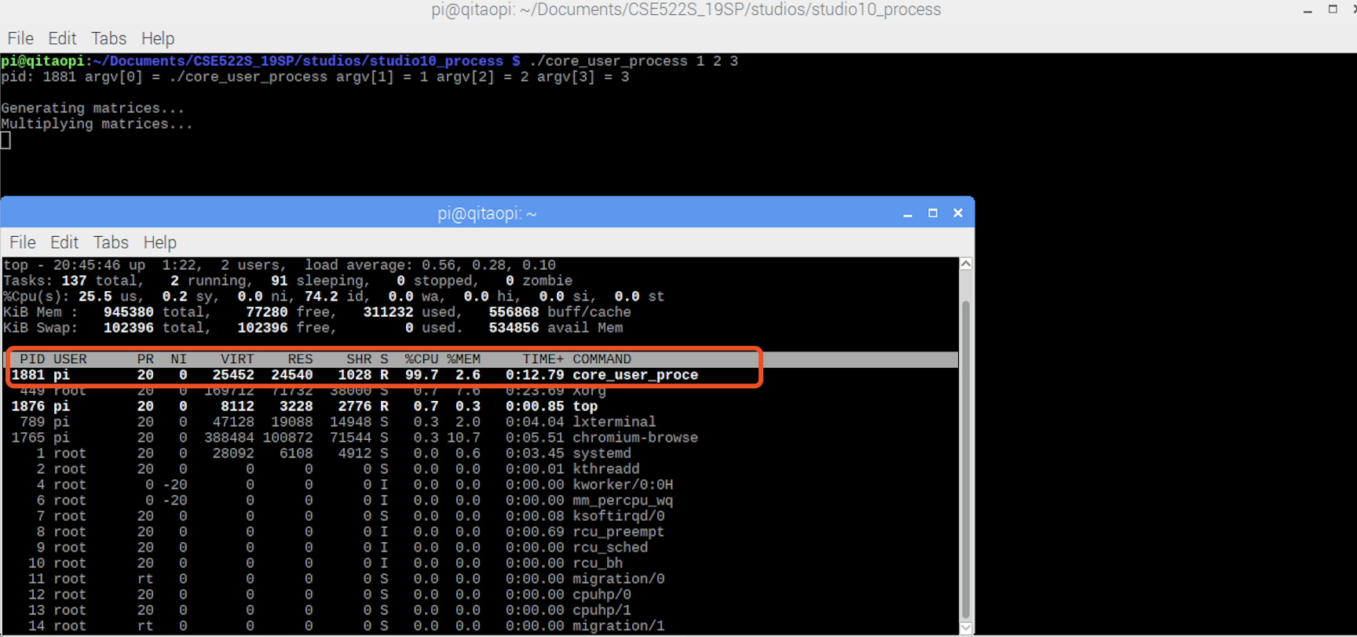

Exercise3:

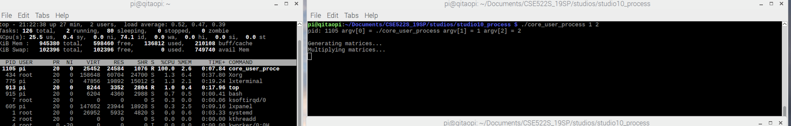

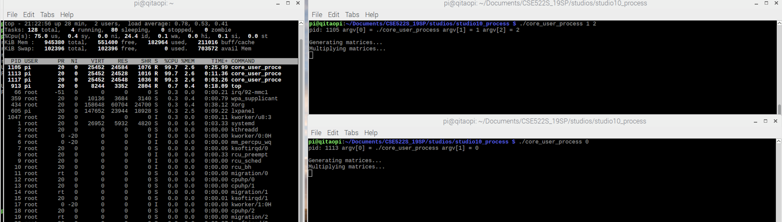

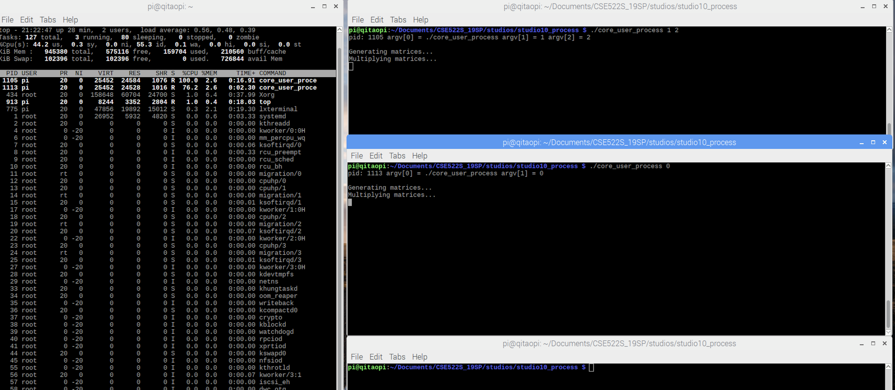

Exercise4:

Cores are not occupied totally until all the cores are assigned.

Exercise5:

The output matches the command line

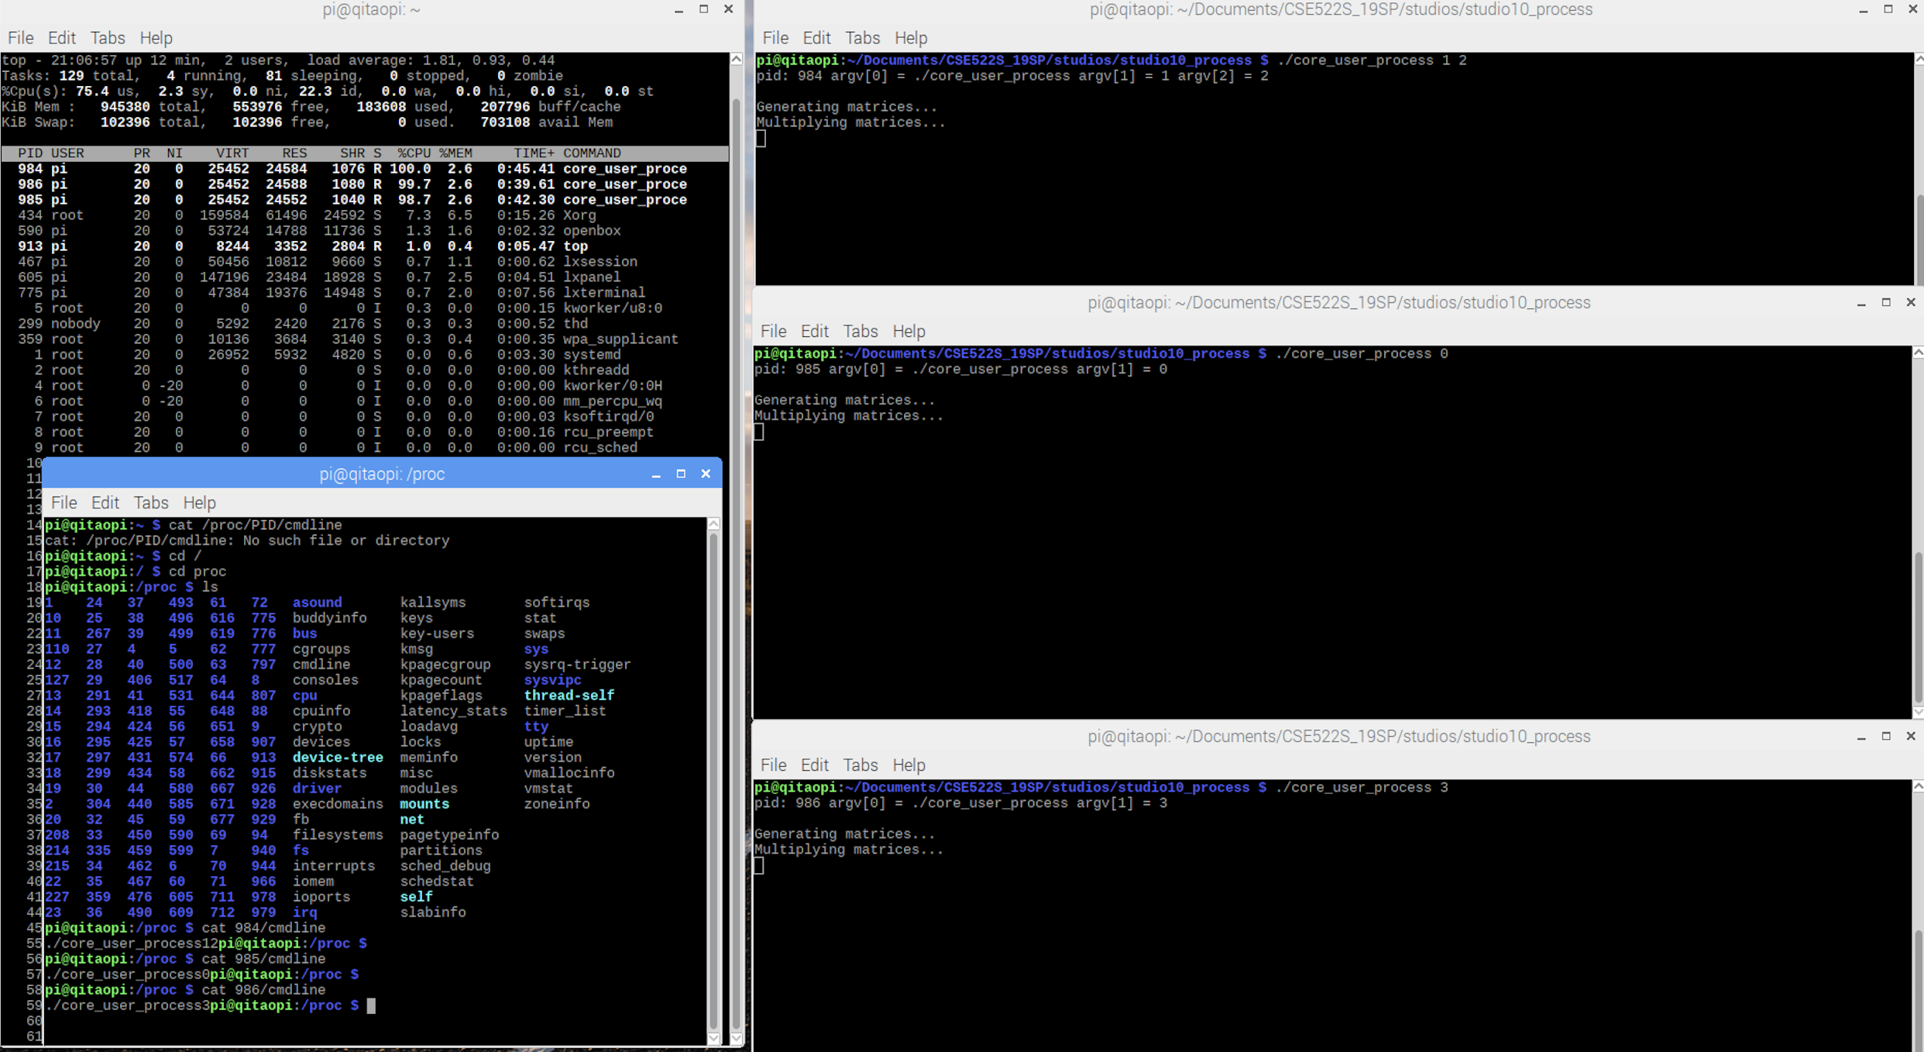

Exercise6:

List of cpus matches our command line.

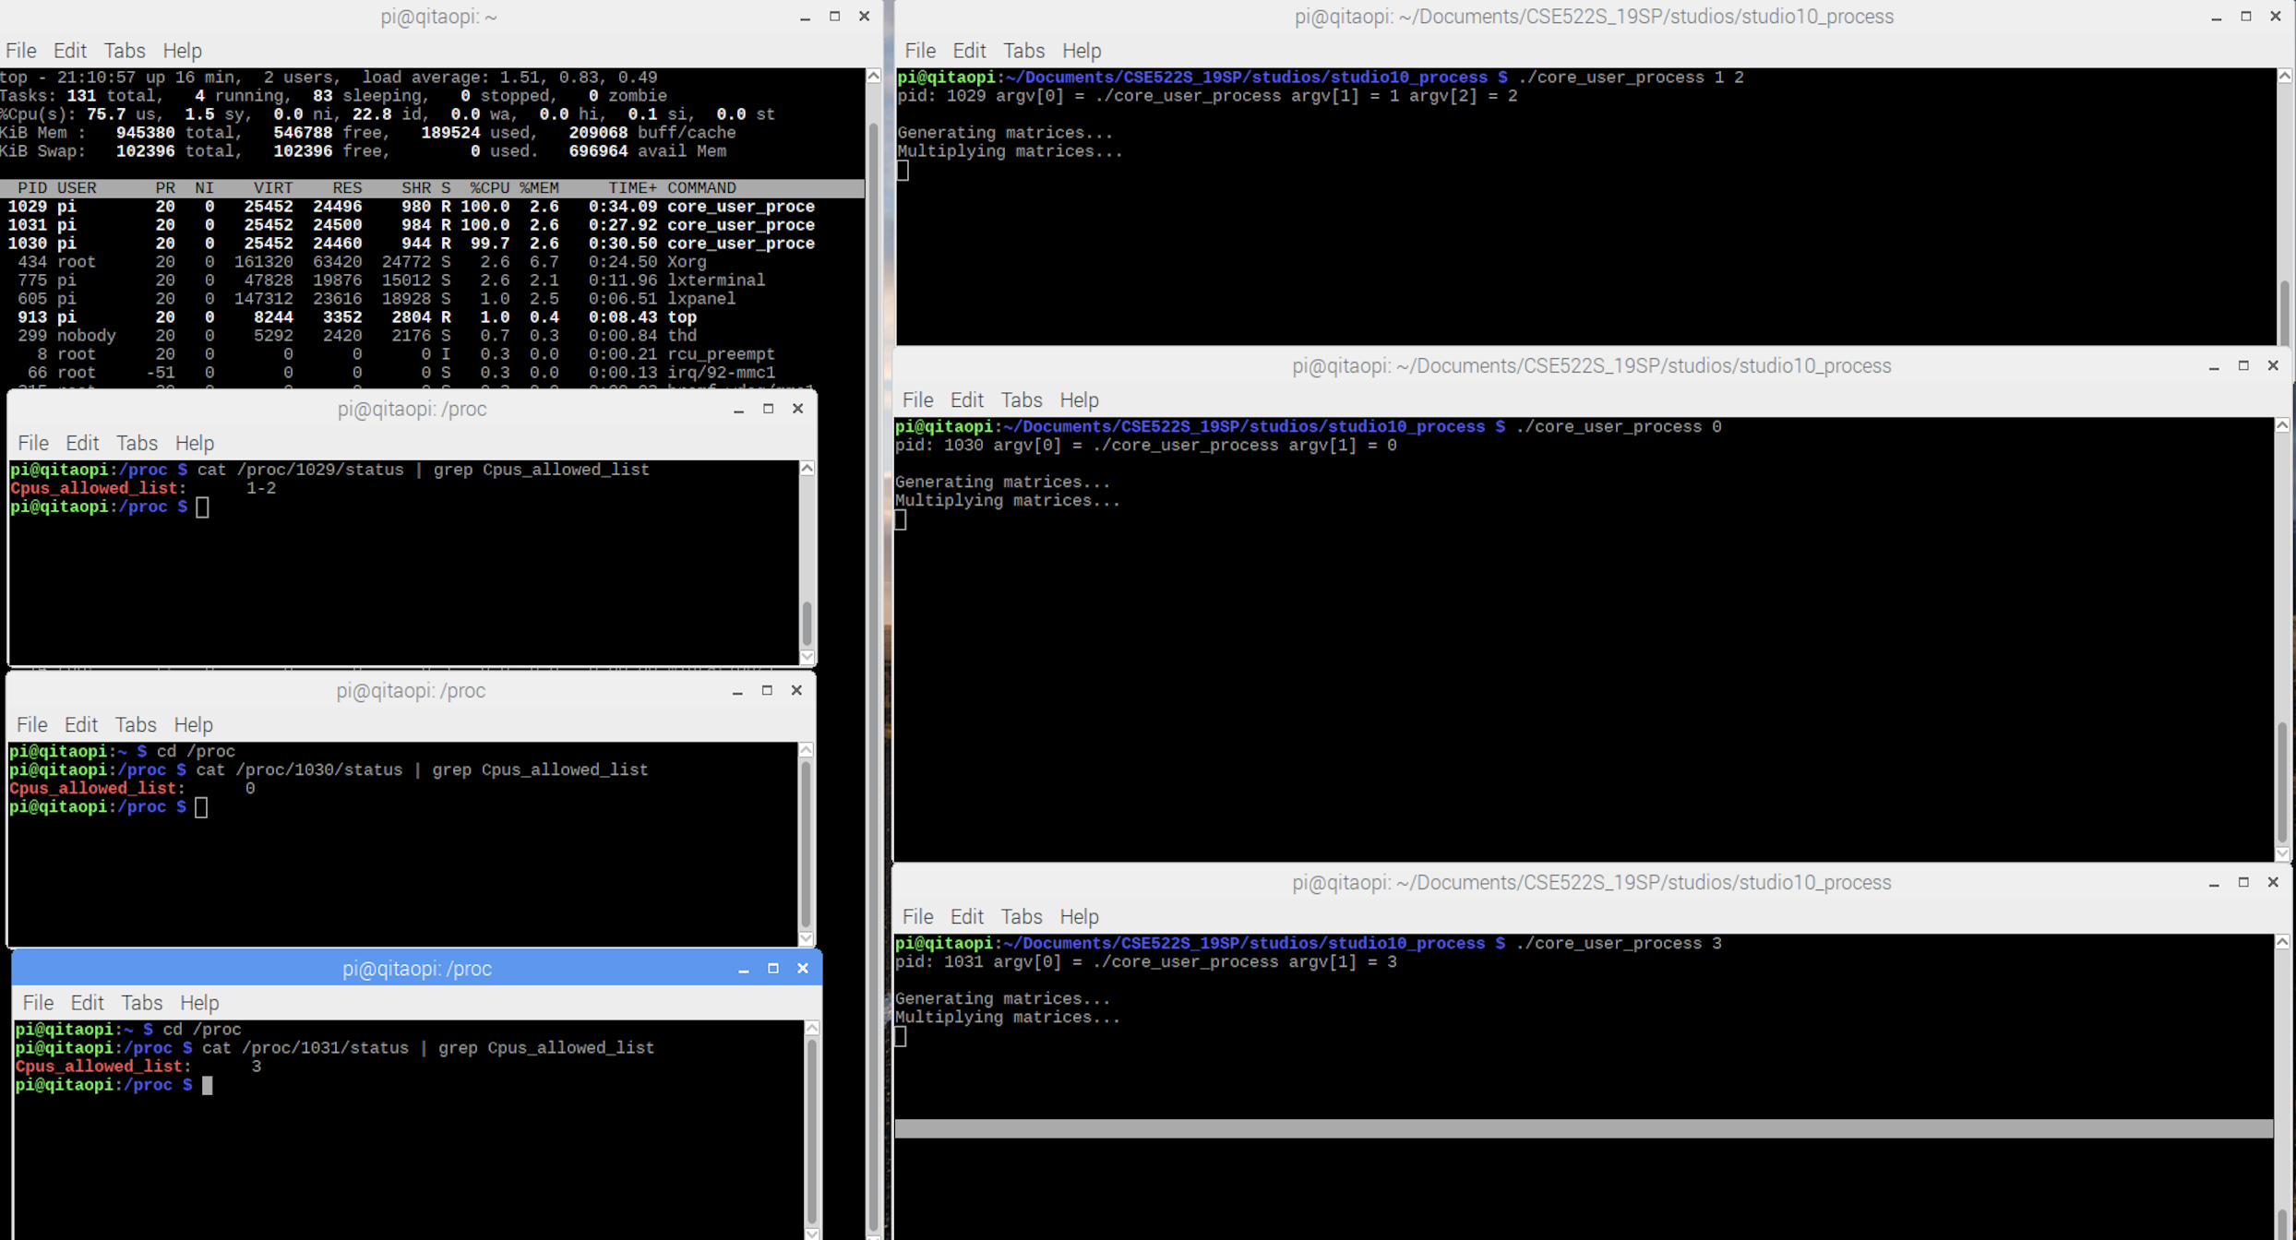

Exercise7:

Voluntary switch can be more when more cores are occupied.

